1. The **Location** field doesn’t show the correct information on the assets.

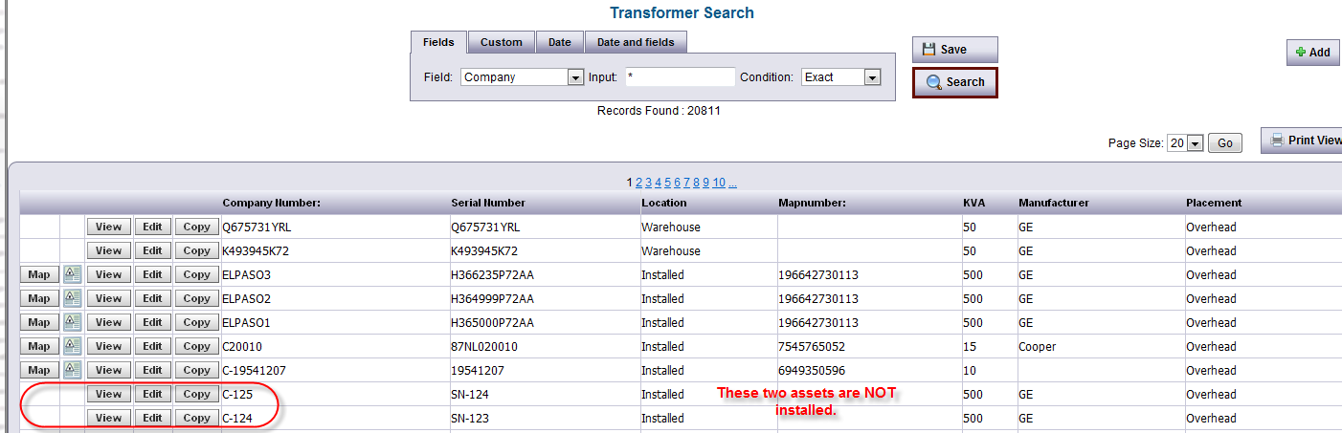

**NOTE:**

*This is NOT a real issue but I don’t know how to fix it.

**2.** **Add** new Fuses creates an error as following;

An error has occurred. Please review the following information and report the error to Futura Systems.

Error: Invalid object name 'LUT_FUSEMODEL'.

Source: .Net SqlClient Data Provider

Trace: at System.Data.SqlClient.SqlConnection.OnError(SqlException exception, Boolean breakConnection)%0d%0a at System.Data.SqlClient.SqlInternalConnection.OnError(SqlException exception, Boolean breakConnection)%0d%0a at System.Data.SqlClient.TdsParser.ThrowExceptionAndWarning(TdsParserStateObject stateObj)%0d%0a at System.Data.SqlClient.TdsParser.Run(RunBehavior runBehavior, SqlCommand cmdHandler, SqlDataReader dataStream, BulkCopySimpleResultSet bulkCopyHandler, TdsParserStateObject stateObj)%0d%0a at System.Data.SqlClient.SqlDataReader.ConsumeMetaData()%0d%0a at System.Data.SqlClient.SqlDataReader.get_MetaData()%0d%0a at System.Data.SqlClient.SqlCommand.FinishExecuteReader(SqlDataReader ds, RunBehavior runBehavior, String resetOptionsString)%0d%0a at System.Data.SqlClient.SqlCommand.RunExecuteReaderTds(CommandBehavior cmdBehavior, RunBehavior runBehavior, Boolean returnStream, Boolean async)%0d%0a at System.Data.SqlClient.SqlCommand.RunExecuteReader(CommandBehavior cmdBehavior, RunBehavior runBehavior, Boolean returnStream, String method, DbAsyncResult result)%0d%0a at System.Data.SqlClient.SqlCommand.RunExecuteReader(CommandBehavior cmdBehavior, RunBehavior runBehavior, Boolean returnStream, String method)%0d%0a at System.Data.SqlClient.SqlCommand.ExecuteReader(CommandBehavior behavior, String method)%0d%0a at System.Data.SqlClient.SqlCommand.ExecuteDbDataReader(CommandBehavior behavior)%0d%0a at System.Data.Common.DbCommand.System.Data.IDbCommand.ExecuteReader(CommandBehavior behavior)%0d%0a at System.Data.Common.DbDataAdapter.FillInternal(DataSet dataset, DataTable[] datatables, Int32 startRecord, Int32 maxRecords, String srcTable, IDbCommand command, CommandBehavior behavior)%0d%0a at System.Data.Common.DbDataAdapter.Fill(DataSet dataSet, Int32 startRecord, Int32 maxRecords, String srcTable, IDbCommand command, CommandBehavior behavior)%0d%0a at System.Data.Common.DbDataAdapter.Fill(DataSet dataSet)%0d%0a at Microsoft.Practices.EnterpriseLibrary.Data.Database.DoLoadDataSet(IDbCommand command, DataSet dataSet, String[] tableNames)%0d%0a at Microsoft.Practices.EnterpriseLibrary.Data.Database.LoadDataSet(DbCommand command, DataSet dataSet, String[] tableNames)%0d%0a at Microsoft.Practices.EnterpriseLibrary.Data.Database.LoadDataSet(DbCommand command, DataSet dataSet, String tableName)%0d%0a at Microsoft.Practices.EnterpriseLibrary.Data.Database.ExecuteDataSet(DbCommand command)%0d%0a at Microsoft.Practices.EnterpriseLibrary.Data.Database.ExecuteDataSet(String storedProcedureName, Object[] parameterValues)%0d%0a at Futura.Web.Framework.XMLConfigHelper.AddControlToTableCell(TableCell

1. **Disconnect** button creates an error some time when I choose a specific warehouse rather than “Disposed” value;

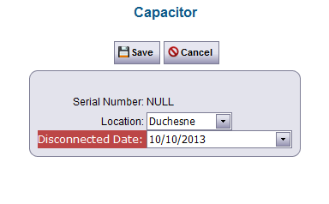

An error has occurred. Please review the following information and report the error to Futura Systems.

Error: 'Comboboxassetcapacitorlocation' has a SelectedValue which is invalid because it does not exist in the list of items.%0d%0aParameter name: value

Source: System.Web

Trace: at System.Web.UI.WebControls.ListControl.set_SelectedValue(String value)%0d%0a at System.Web.UI.WebControls.ListControl.set_Text(String value)%0d%0a at Futura.Web.ProjectTracker.ATAssetEquip.UpdateAsset()%0d%0a at Futura.Web.ProjectTracker.ATAssetEquip.btnSave_Click(Object sender, EventArgs e)%0d%0a at DevExpress.Web.ASPxEditors.ASPxButton.OnClick(EventArgs e)%0d%0a at DevExpress.Web.ASPxEditors.ASPxButton.RaisePostBackEvent(String eventArgument)%0d%0a at DevExpress.Web.ASPxClasses.ASPxWebControl.System.Web.UI.IPostBackEventHandler.RaisePostBackEvent(String eventArgument)%0d%0a at System.Web.UI.Page.RaisePostBackEvent(IPostBackEventHandler sourceControl, String eventArgument)%0d%0a at System.Web.UI.Page.RaisePostBackEvent(NameValueCollection postData)%0d%0a at System.Web.UI.Page.ProcessRequestMain(Boolean includeStagesBeforeAsyncPoint, Boolean includeStagesAfterAsyncPoint) .

**NOTE:**

*This is NOT a real error. I read the text of the error but I’m not sure where I should look on the Setuppage🡪Manage XML Configuration to fix this issue.

1. **Batch Copy Asset** commands create errors when I clicked on *Save* button. The text of error is not true; see the screen shot from the **Reclosers** tab.

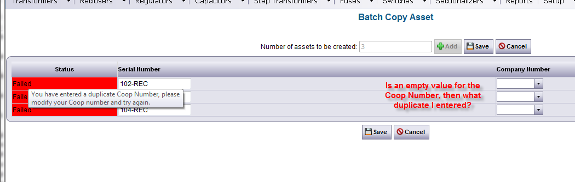

**NOTE:**

**\***I mention that I don’t have an **Auto Number Configuration** set for ***AssetRecloser*** on “CoopNumber”. Anyway after I set this autonumber I’m getting the same error.

1. Missing the **Custom** button from the *Fuses*, *Switches* and *Sectionalizers* assets Search pages and on the Step Transformer Search page is not displayed any custom search;

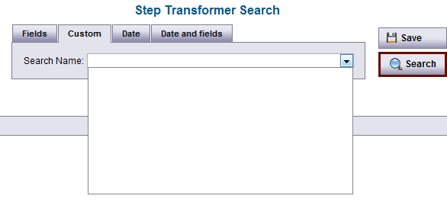

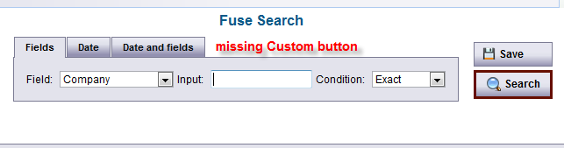

**NOTE:**

*This is NOT a real error. I know that this “**Custom**” button is not displayed on the assets page if is not configured any custom search on the **Setup page**🡪**Manage Custom Searches**.

I looked on **Custom Search** page and there I don’t have either any custom search configuration set for Step Transformer assets but the Custom button is displayed, so in this case I’m not sure what the correct way is.

1. **Map View** button doesn’t zoom to a real location on the map, even that its open the WebMap, which is not point the correct data and version.

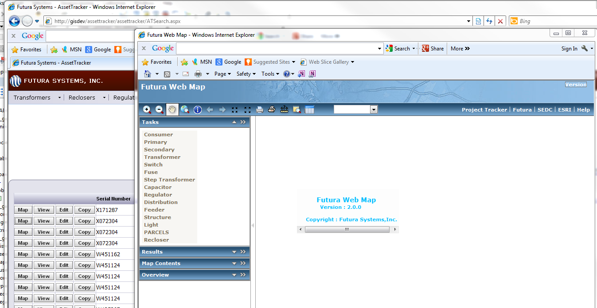

1. According with the **Test Case# 649** from DEVConsole, the changes made in Asset Tracker is NOT push to UPN and vice-versa.
2. **REPORTS-** Theoretically I know how to relink data to the stored procedure for an existing report but unfortunately only one report I was able to make it work….

* After I run this Report name “**Transformer By Location**”, I saw two issues, see screen shot;

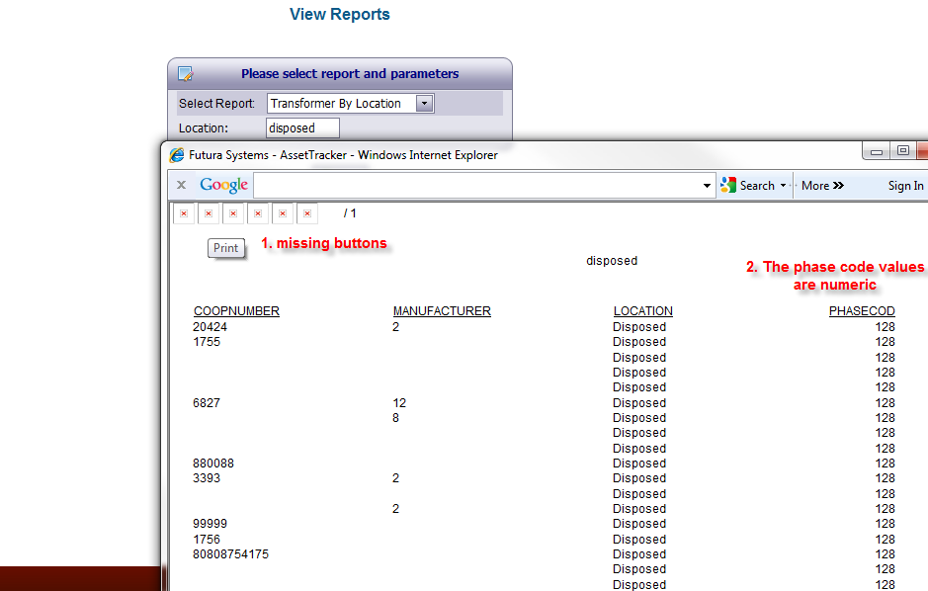

1. I configured two DB connections and I tried to run the above report “Transformer By Location” on these two connection separately and I’m getting an error when I run under FGDB connection.

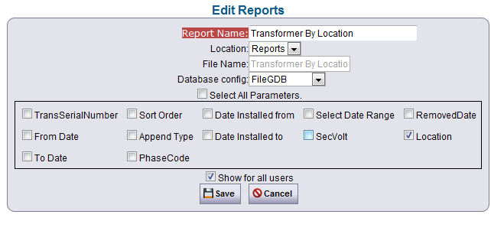

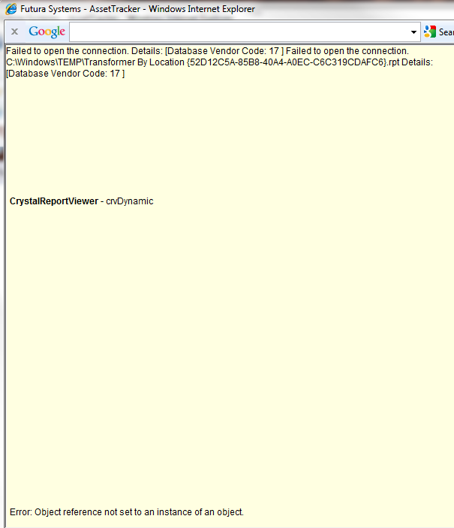

1. In **Custom Search** the **Print View** doesn’t work.

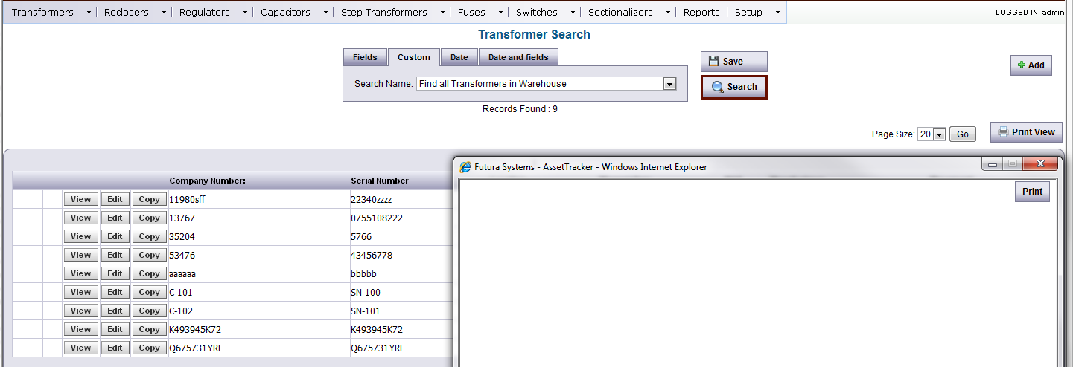

**NOTE:**

**\*This is the subject of work order # 2941**

1. I noticed that when I run a **Date** search the results are not removed when I clicked on the **Date and fields** search tab to make a new search.

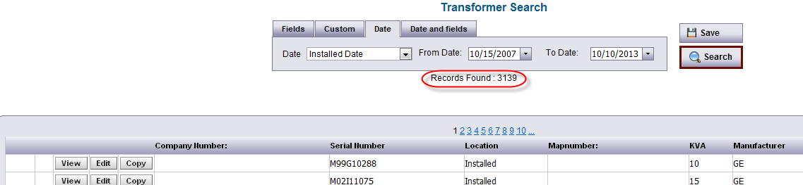

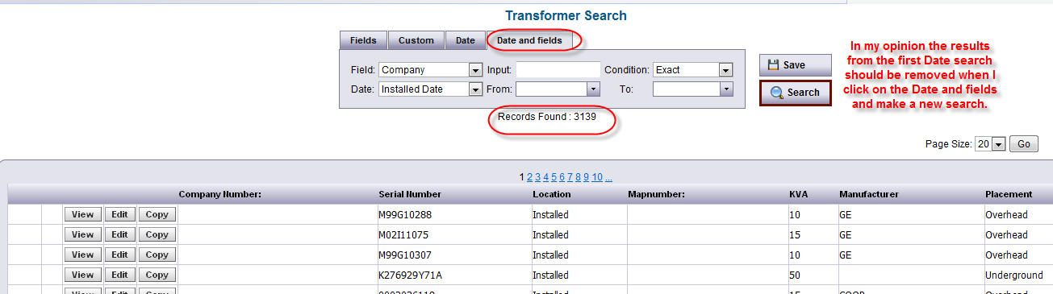

1. **Transformer Load** is not working because the **Consumer** feature class doesn’t have the **KW** and **KWh** fields and the **UsageData** table is not populated.

